# **Figures and Tables – Killer whale respiration rates**

**Table 1. Summary of data collected on 11 resident killer whales.** Whale ID’s, sexes, birth years, and ages of 9 northern (NRKW) and 2 southern resident (SRKW) killer whales when they were equipped with biologging devices in 2020. Ages were calculated based on a catalogue of known individuals and birth dates (Towers et al., 2020, Center for Whale Research, 2023). Total individual dives on CATS tags were 3163 for females, and 4955 for males. Also shown are the number of individual surface intervals (equivalent to number of individual dives) recorded by the drone video and CATS tag for each whale along with CATS tag attachment durations.

|  |  |  |  |  |  |  |  |  |
| --- | --- | --- | --- | --- | --- | --- | --- | --- |
| **Whale ID** | **Sex** | **Type** | **Birth** | **Age** | **Tag Date 2020** | **Total Surface Intervals on Drone** | **Total Surface Intervals on CATS Tag** | **CATS Tag attachment duration (hours)** |
| A113 | Female | NRKW | 2016 | 4 | Aug. 22 | 264 | 872 | 7.4 |
| R48 | Female | NRKW | 2006 | 14 | Aug. 28 | 30 | 310 | 4.7 |
| A100 | Unknown | NRKW | 2011 | 9 | Aug. 20 | 4 | 356 | 3.6 |
| R58 | Unknown | NRKW | 2011 | 9 | Aug. 28 | 20 | 94 | 1.4 |
| I145 | Unknown | NRKW | 2014 | 6 | Aug. 30 | 12 | 461 | 5.1 |
| D26 | Unknown | NRKW | 2010 | 10 | Aug. 31 | 59 | 575 | 6.4 |
| I129 | Unknown | NRKW | 2009 | 11 | Aug. 30 | No video | 495 | 6.2 |
| I107 | Male | NRKW | 2004 | 16 | Aug. 25 | 66 | 1378 | 12.3 |
| D21 | Male | NRKW | 2005 | 15 | Aug. 31 | 21 | 1812 | 19.9 |
| L87 | Male | SRKW | 1992 | 28 | Sept. 10 | No video | 963 | 8.7 |
| L88 | Male | SRKW | 1993 | 27 | Sept. 10 | No video | 802 | 8.3 |
|  |  |  |  |  |  | **Total = 476** | **Total = 8118** |  |

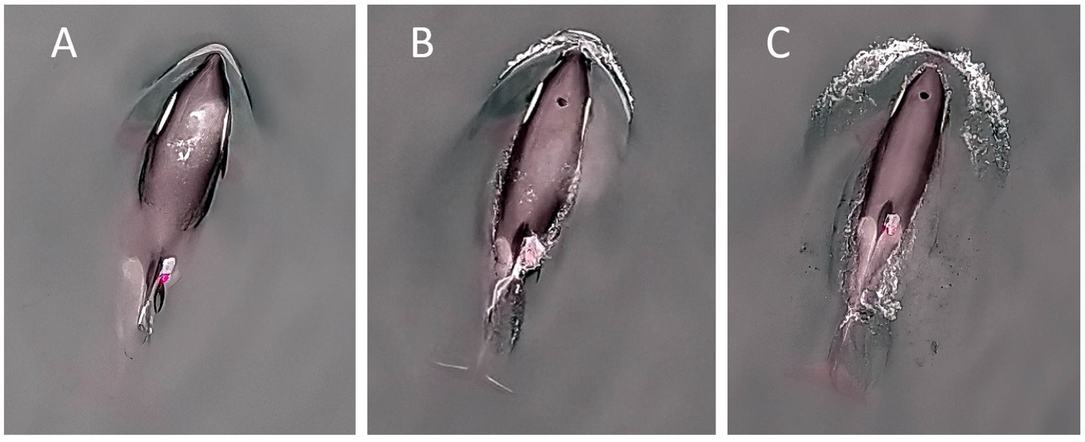

**Fig 1.** **Still images from UAV drone video showing datalogger placement and respiration.** Photographs showing the CATS datalogger attached with suction cups to a female northern resident killer whale (A113). Views show (A) the whale’s breath immediately after surfacing, (B) mid-blow, and (C) after the blow has dissipated. Photo credit: Keith Holmes.

**Table 2. Defined behavioural states of northern and southern resident killer whales observed on drone video.**  Travelling, foraging, logging, and resting were defined according to definitions used in other killer whale studies (Noren and Hauser, 2016, Miller et al., 2010). See methods for details.

|  |  |
| --- | --- |
| **Behavioural state** | **Definition** |
| Travelling | Moving in the same general direction between surfaces at a constant pace, often with other whales present in a group. Very consistent dive and surface interval durations with more consistent depth. Max dive depth travelling was qualitatively less variable compared to foraging. |
| Foraging | Not moving in the same general direction and not moving at a constant pace; often with longer dives between surfaces; often dolphins are present; often the focal whale is alone or with few other whales. Max dive depth shallow foraging was more variable than travelling based on video observations. |
| Resting | Swimming at a very slow speed with other whales present in a group; not making any significant progress in one direction; includes shallow diving and surfacing. |
| Logging | Stationary at the surface with other whales present in a group; synchronized breathing within the group; does not include shallow diving and surfacing (blowhole may or may not be submerged; a portion of the dorsal fin remains above the water). |

**Table 3**. **Contingency matrix used to assess how well the HHMM predicted the behavioural state of killer whales observed on drone video.** Drone video observations of behavioural states (“Truth”) were compared to HHMM predicted behavioural states (“Estimate”) using a k-fold cross-validation on animals that had concurrent video to yield a confusion matrix (contingency table) per behavioural state for foraging, resting, and travelling tracks. This particular contingency table was used to measure error in identifying foraging behavior, and was repeated for resting and travelling. Sample size of whales for all behavioural states was n=7 females and n=4 males.

|  |  |  |  |
| --- | --- | --- | --- |
|  | **Drone video observed**  **(Truth)** | **HHMM predicted**  **(Estimate)** | **Description** |
| **True Positive (TP)** | Yes | Yes | Both drone video and HHMM identified behaviour of track as foraging. |
| **True Negative (TN)** | No | No | Both drone video and HHMM identified behaviour of track as any behaviour *except* foraging. |
| **False Positive (FP)** | No | yes | HHMM identified track as foraging, but drone video observed any behaviour *except* foraging. |
| **False Negative (FN)** | Yes | No | HHMM identified behaviour of track as any behaviour *except* foraging, but drone video observed foraging |

**Table 4**. **Total number of tracks and activity budget per behavioural state of resident killer whales predicted by the hierarchical hidden Markov models (HHMM).** Only tracks that were **≥** 10.0 minutes were used in the subsequent respiration rate analysis (females=176, and males=243 tracks). Logging did not occur in durations **≥** 10 minutes and was excluded from the respiration rate analysis. Killer whales of unknown sexes were assumed to be femalesa. Sample size of whales for all behaviours was n=7 females and n=4 males.

|  |  |  |  |  |  |  |  |
| --- | --- | --- | --- | --- | --- | --- | --- |
|  | **Behavioural state** | **Predicted by HHMM (counts)** | | **Activity Budget (%)** | **Cumulative duration of tracks**  **(≥ 10 min)** | | |
| **Total** | **≥ 10 min** | **Mean** | **Mean** | **S.D.** | **Range** |
| **Females** | Resting | 76 | 70 | 39.8 | 11.6 | 1.5 | 10.0-16.0 |
| Foraging | 40 | 38 | 21.6 | 11.2 | 1.6 | 10.0-17.2 |
| Travelling | 75 | 68 | 38.6 | 10.6 | 1.1 | 10.0-15.0 |
| **Males** | Resting | 100 | 90 | 37.0 | 10.9 | 1.0 | 10.0-13.9 |
| Foraging | 76 | 62 | 25.5 | 11.1 | 1.7 | 10.0-16.9 |
| Travelling | 103 | 91 | 37.5 | 10.3 | 0.3 | 10.0-11.3 |

a Unknown individuals were categorized as females for HHMM based on likelihood of similar morphometrics.

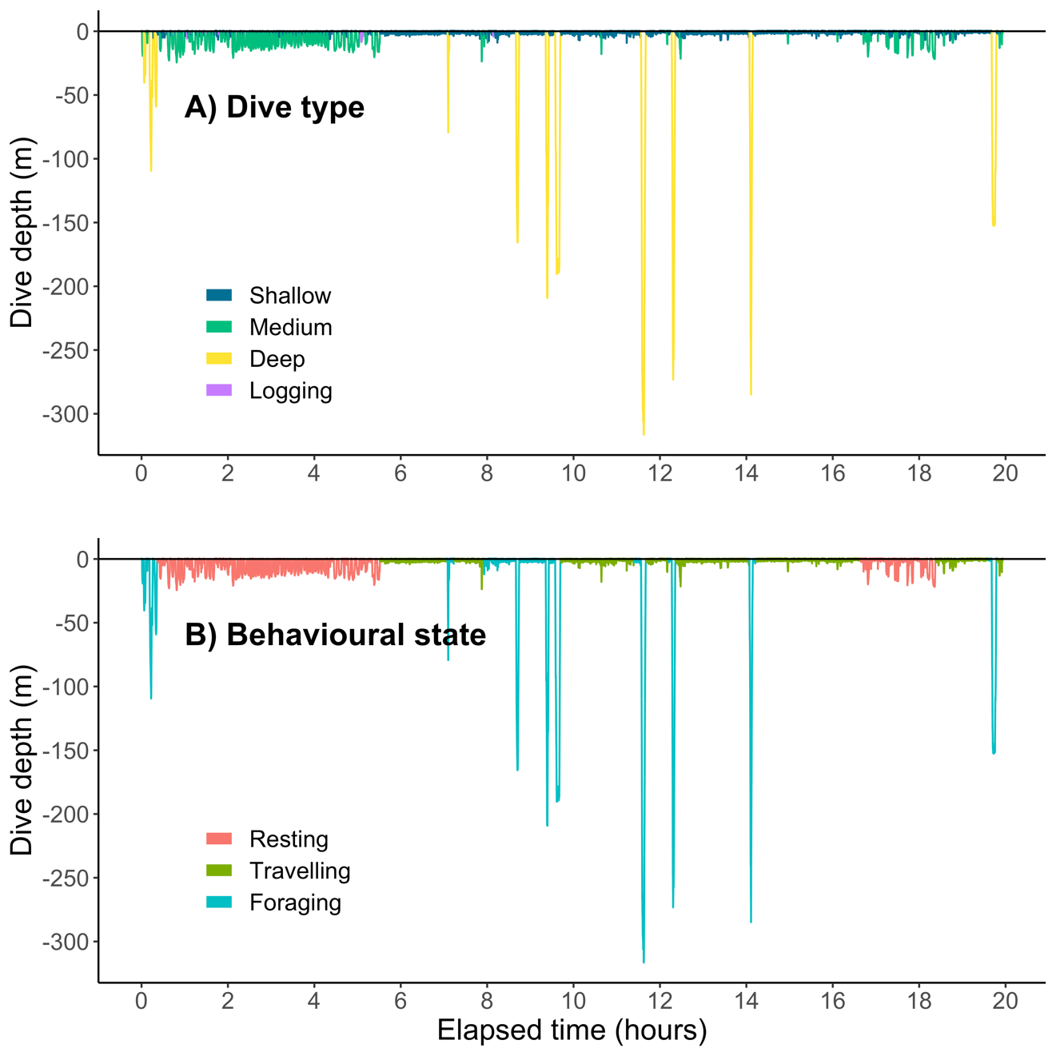

**Fig 2. Example of a dive-depth profile from whale D21 illustrating depth categories and track behavioural states predicted by the HHMM.** Panel A represents the depth categories used to classify behavioural states within the HHMM. On D21, sample sizes were logging (n=27), shallow (< 7.5m, n=1,687) medium (10-30 m, n=87), and deep (> 50m, n=11, see S1 for details). Panel B represents predicted behavioural states by the HHMM for resting (n = 550 dives), travelling (n = 1005 dives), and foraging (n = 257 dives) on this animal. This male whale performed 1812 total individual dives on the CATS tag.

**Table 5**: **Summary of HHMM measures of error predicting behavioural state of killer whales relative to drone video observations.** True behavioural state labels from drone videos were compared with predicted labels generated from the HHMM to assess the model’s ability to accurately label the behaviour of a new whale without video-generated labels. Measures of error were calculated at the level of the track as percentages and included detection (TP/(TP+FN)), false positive rate (FP/(FP+TP)), precision (TP/(TP+FP)) specificity (TN/(TN+FP)) and accuracy ((TP+TN)/(TP+TN+FP+FN)). Error was only assessed on tracks that had video labels (females = 66 video-labelled out of 176 total tracks predicted; males = 62 video-labelled out of 243 total tracks predicted). See Table 3 for conceptual definitions of contingency matrix. Sample size of whales for all behaviours was n=7 females and n=4 males.

|  |  |  |  |  |  |  |  |  |  |  |
| --- | --- | --- | --- | --- | --- | --- | --- | --- | --- | --- |
|  | | **Total count** | | | | **Measures of Error (%)** | | | | |
| **TP\*** | **FN\*** | **FP\*** | **TN\*** | **Detection** | **FP Rate** | **Precision** | **Specificity** | **Accuracy** |
| **Females** | Resting | 5 | 4 | 6 | 51 | 56 | 55 | 45 | 89 | 85 |
| Foraging | 21 | 1 | 9 | 35 | 95 | 30 | 70 | 80 | 85 |
| Travelling | 25 | 10 | 0 | 31 | 71 | 0 | 100 | 100 | 85 |
| **Males** | Resting | 5 | 0 | 1 | 56 | 100 | 17 | 83 | 98 | 98 |
| Foraging | 55 | 2 | 0 | 5 | 96 | 0 | 100 | 100 | 97 |
| Travelling | 0 | 0 | 1 | 61 | NA | 100 | 0 | 98 | 98 |

* TP = true positive, FN = false negative, FP = false positive, TN = true negative. See Table 3.



**Fig 3.** **Respiration rates (breaths min-1) of 7 female and 4 male resident killer whales while resting, foraging, and travelling.** Respiration rates were calculated for each behavioural state by dividing the cumulative duration by the total number of surface intervals within the track per behavioural state as identified by the HHMM for tracks **≥** 10 minutes. Males and females were modelled separately, and sex was not tested as a fixed factor. Numbers of tracks were 70-resting, 38-foraging, and 68-travelling for females—and 90-resting, 62-foraging, and 91-travelling for males. Sample size of whales across all behaviours was n=7 females and n=4 males.



**Fig 4. Individual long dive durations (≥ 1 minute) of 7 female and 4 male resident killer whales for different behavioural states (foraging, resting, and travelling).** Individual dive duration was recorded by the CATS tags with behavioural state as predicted by the HHMM. Long dives include 11% of the total dives in females (n=354 long dives) and 9% of the total dives in males (n=440 long dives). Sample sizes for total individual dives≥ 1 minute are females: n=76-foraging, 190-resting, and 88-travelling dives; males: n=93-foraging, 241-resting, 106-travelling dives.

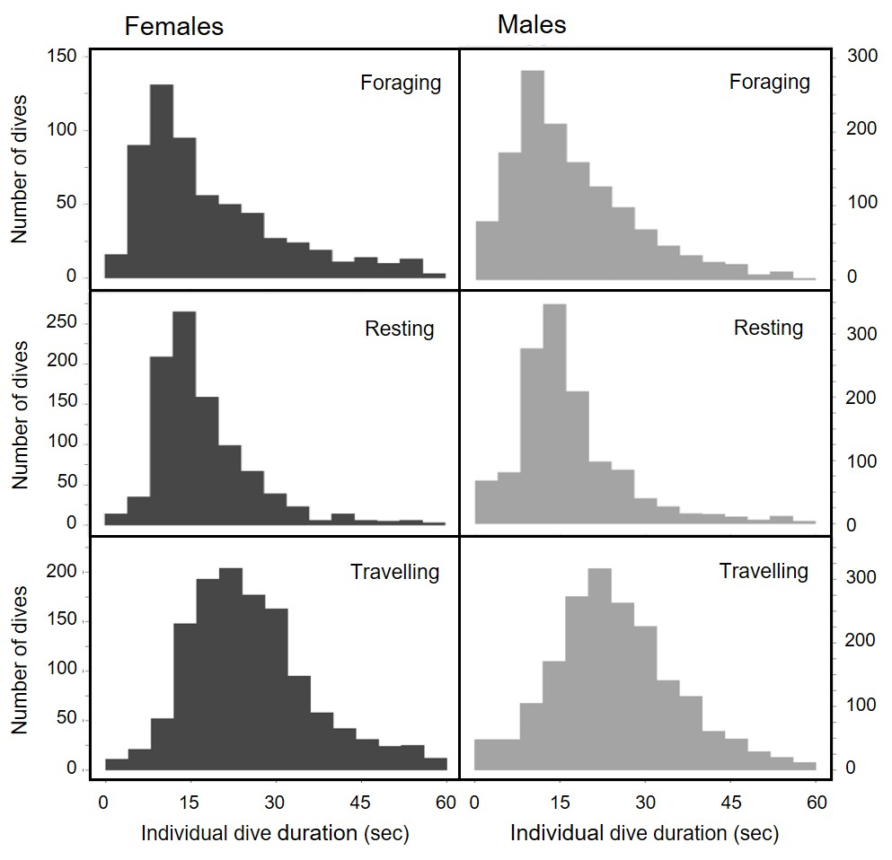

**Fig 5. Distributions of individual dive durations for short dives (< 1 minute) from CATS tags with behavioural state predicted by HHMM (bins = 4 seconds).** Individual dive duration was recorded by the CATS tags with behavioural state predicted by the HHMM. Short dives were 89% of the total dives in females (n=2899 short dives) and 91% of the total dives in males (n=4515 short dives). Sample sizes for total individual short dives< 1 minute are females: n=603-foraging, 950-resting, and 1256-travelling dives; males: n=1340-foraging, 1296-resting, 1879-travelling dives.

**Table 6. Example of calculated oxygen consumption rates (VO2 fixed) of 11 resident killer whales derived from respiration data with fixed tidal volumes per sex.** Sample size of whales for all behaviours was n=7 females and n=4 male whalesa. Sex, behavioural state, sample size of respirations at the level of the track (N, females=176, males=243), assumed oxygen extraction from inhaled air (EO2, %), and oxygen uptake per respiration (TO2, L O2 breath-1) used to calculate mean (+ standard deviation) oxygen consumption (VO2 fixed, L O2 min-1) and (VO2 fixed, L O2 sec-1) from respiration rates.

|  |  |  |  |  |  |  |  |  |  |  |  |
| --- | --- | --- | --- | --- | --- | --- | --- | --- | --- | --- | --- |
|  |  | **Tracks** | **Maximum fixed VT** | **EO2b** | **TO2** | **Calculated VO2 fixed**  **(L O2 min -1)c** | | | **Calculated VO2 fixed**  **(L O2 sec -1)c** | | |
|  | **Behavioural state** | **N** | **(L)** | **(%)b** | **(L O2 breath-1)b** | **Mean** | **S.D.** | **Range** | **Mean** | **S.D.** | **Range** |
| **Female** | Resting | 70 | 149.0 | 35.1 | 10.96 | 13.6 | 3.36 | 5.8-21.9 | 0.2 | 0.06 | 0.1-0.4 |
| Foraging | 38 | 149.0 | 40.1 | 12.50 | 18.1 | 6.18 | 6.5-39.7 | 0.3 | 0.1 | 0.1-0.7 |
| Travelling | 68 | 149.0 | 40.1 | 12.50 | 20.5 | 4.64 | 9.2-29.5 | 0.3 | 0.08 | 0.2-0.5 |
| **Male** | Resting | 90 | 258.5 | 38.4 | 20.80 | 27.9 | 5.70 | 15.8-40.3 | 0.5 | 0.10 | 0.3-0.7 |
| Foraging | 62 | 258.5 | 43.7 | 23.68 | 40.4 | 15.54 | 16.2-86.1 | 0.7 | 0.26 | 0.3-1.4 |
| Travelling | 91 | 258.5 | 43.7 | 23.68 | 42.1 | 8.48 | 28.0-66.9 | 0.7 | 0.14 | 0.5-1.1 |

a Individuals of unknown sex were categorized as females for VO2 calculation only based on likelihood of having similar morphometrics.

b Mean oxygen extraction from inhaled air (EO2) for resting was from activity level 1, and foraging and travelling was from activity level 2 for both sexes (Table 9, Kriete, 1995). For males only, EO2 for activity level 2 was averaged from activity levels 1 and 3 values for both whales because it was not directly measured, then the averages per whale of activity level 2 (41.15, 46.3 %) were averaged to yield a single mean EO2 for all males in activity level 2. This resulted in fixed oxygen uptake per respiration per sex per behavior (TO2, L respiration-1). For all calculations, we assumed the proportion of oxygen in air was 0.2095.

c Oxygen consumption (VO2 fixed, L O2 min-1 or sec-1) was calculated per track using Equation 1 in Roos et al. (2016) with values originally measured by Kriete (1995). This equation used the following parameters based on Kriete (1995). Maximum tidal lung volume (VT) per sex was fixed and did not vary by body mass or activity level (Table 1, Kriete, 1995).

*All values in the able are rounded for simplicity, but calculations were carried out without rounding digits.

**Table 7. Example of calculated oxygen consumption rates (VO2 mass-specific) of 6 resident killer whales derived from respiration data at the level of the track with mass-specific tidal volumes per sex.** Sample size of whales for all behaviours was n=4 female whales and n=2 male whalesa. See Table S2 for details on calculations as well as predicted body length (cm), predicted body mass (kg), and mass-specific tidal volume (VT) per whale used to calculate VO2 mass-specific.

|  |  |  |  |  |  |  |  |  |
| --- | --- | --- | --- | --- | --- | --- | --- | --- |
|  | **Behavioural state** | **Tracks** | **Calculated VO2 mass-specific**  **(L O2 min -1)b** | | | **Calculated VO2 mass-specific**  **(L O2 sec -1)b** | | |
| **N** | **Mean** | **S.D.** | **Range** | **Mean** | **S.D.** | **Range** |
| **Female** | Resting | 38 | 6.7 | 4.0 | 2.5-18.3 | 0.11 | 0.07 | 0.04–0.30 |
| Foraging | 14 | 7.3 | 1.9 | 3.9–12.1 | 0.12 | 0.03 | 0.07–0.20 |
| Travelling | 28 | 7.4 | 1.8 | 3.7-11.9 | 0.12 | 0.03 | 0.06–0.20 |
| **Male** | Resting | 47 | 25.8 | 5.1 | 14.3-35.0 | 0.43 | 0.09 | 0.24-0.58 |
| Foragingc | 7 | 35.2 | 9.1 | 19.3-44.1 | 0.59 | 0.15 | 0.32-0.74 |
| Travelling | 35 | 43.6 | 5.8 | 32.0-59.8 | 0.73 | 0.10 | 0.53-1.0 |

a Animals A113, I129, I145, I107, and D21 were excluded from VO2 mass-specific calculations because predicted body masses were not within 15% of the predicted body masses and sex-specific VT of the killer whales in (Table 16, Kriete, 1995).

b Oxygen consumption (VO2 mass-specific, L O2 min-1 or sec-1) was calculated per track (only tracks ≥ 10 min cumulative duration) using Equation 1 in Roos et al. (2016) with mass-specific values originally measured by Kriete (1995). Maximum tidal lung volume varied by predicted body mass and activity level (Table 1, Kriete, 1995). Mean oxygen extraction from inhaled air (EO2) for resting was from activity level 1, and foraging and travelling was from activity level 2 per sex per animal of similar body mass (Table 9, Kriete, 1995). For males only, VT and EO2 for activity level 2 was averaged from activity levels 1 and 3 values for Hyak because it was not directly measured in Kriete (1995).

c VO2 mass-specific for foraging males only includes whale L87 because L88 had no foraging tracks.

*All values in the able are rounded for simplicity, but calculations were carried out without rounding.

**References**

CENTER FOR WHALE RESEARCH. 2023. *Orca Identification,* [Online]. USA. Available: <https://www.whaleresearch.com/orca-id> [Accessed 2023].

KRIETE, B. 1995. *Bioenergetics in the killer whale, Orcinus orca.* Doctoral Dissertation, University of British Columbia.

MILLER, P. J. O., SHAPIRO, A. D. & DEECKE, V. B. 2010. The diving behaviour of mammal-eating killer whales (*Orcinus orca*): variations with ecological not physiological factors. *Canadian Journal of Zoology,* 88**,** 1103-1112.

NOREN, D. P. & HAUSER, D. D. 2016. Surface-based observations can be used to assess behavior and fine-scale habitat use by an endangered killer whale (*Orcinus orca*) population. *Aquatic Mammals,* 42.

ROOS, M. M., WU, G.-M. & MILLER, P. J. 2016. The significance of respiration timing in the energetics estimates of free-ranging killer whales (*Orcinus orca*). *Journal of Experimental Biology,* 219**,** 2066-2077.

TOWERS, J. R., PIKINGTON, J. F., GISBORNE, B., WRIGHT, B. M., ELLIS, G., FORD, J. & DONIOL-VALCROZE, T. 2020. Photo-identification catalogue and status of the northern resident killer whale population in 2019. *In:* FISHERIES & OCEANS CANADA (ed.) *Canadian Technical Report of Fisheries and Aquatic Sciences.* Nanaimo, BC.